LAPORAN PRAKTIKUM
MATA KULIAH PEMROGRAMAN WEB



Oleh:
Haikal Syawal Al Bukhari-707012500001
D4SIKC 49-04

PROGRAM STUDI S.Ter SISTEM INFORMASI KOTA CERDAS
FAKULTAS ILMU TERAPAN
UNIVERSITAS TELKOM
BANDUNG
2026

Tujuan Praktikum
Praktikum ini bertujuan agar mahasiswa mampu memahami cara menyambungkan database MySQL

Alat dan Bahan
- Laptop
- Internet
- Software

Langkah – Langkah Praktikum
Baca modul yang diberikan terlebih dahulu, lalu kerjakan di VSCode
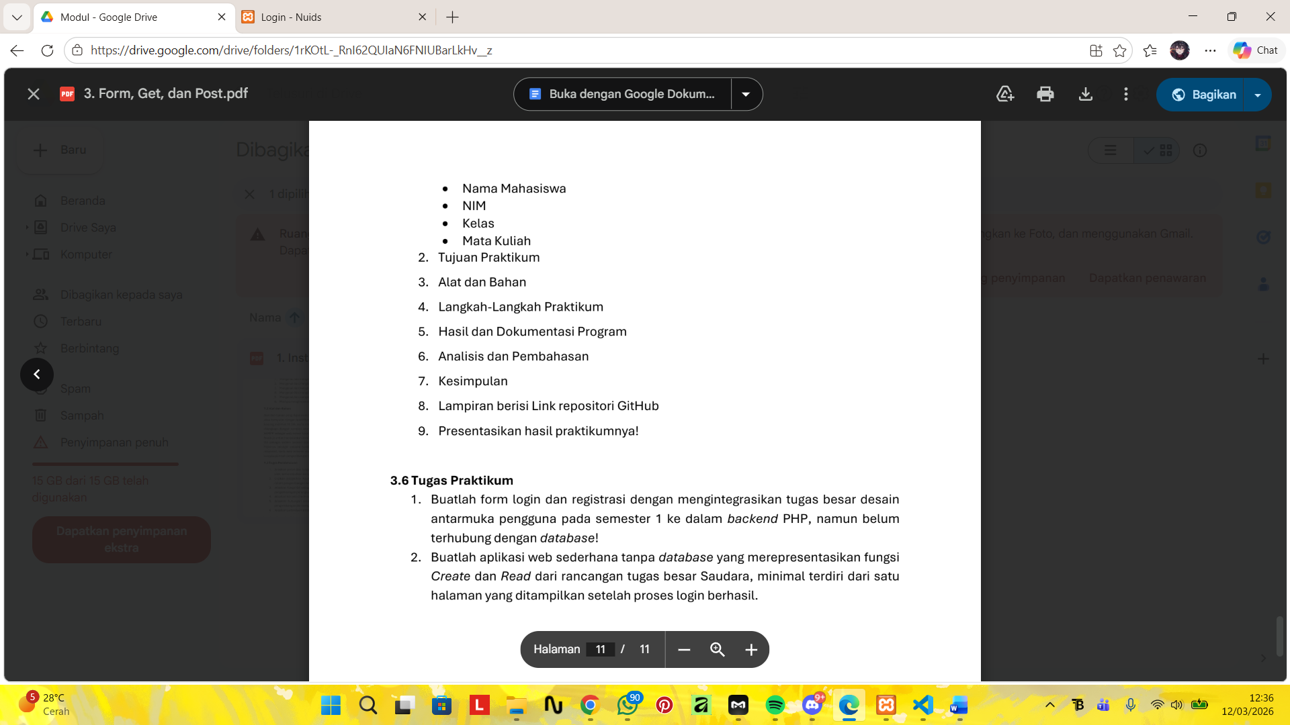
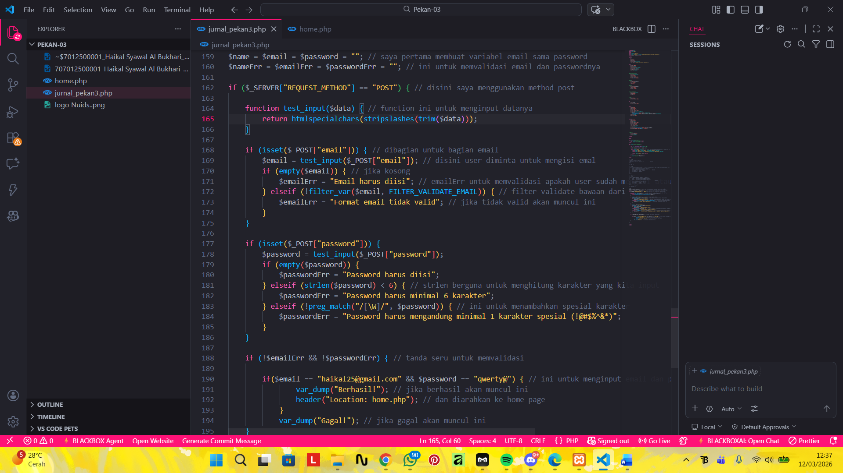

Hasil dan Program

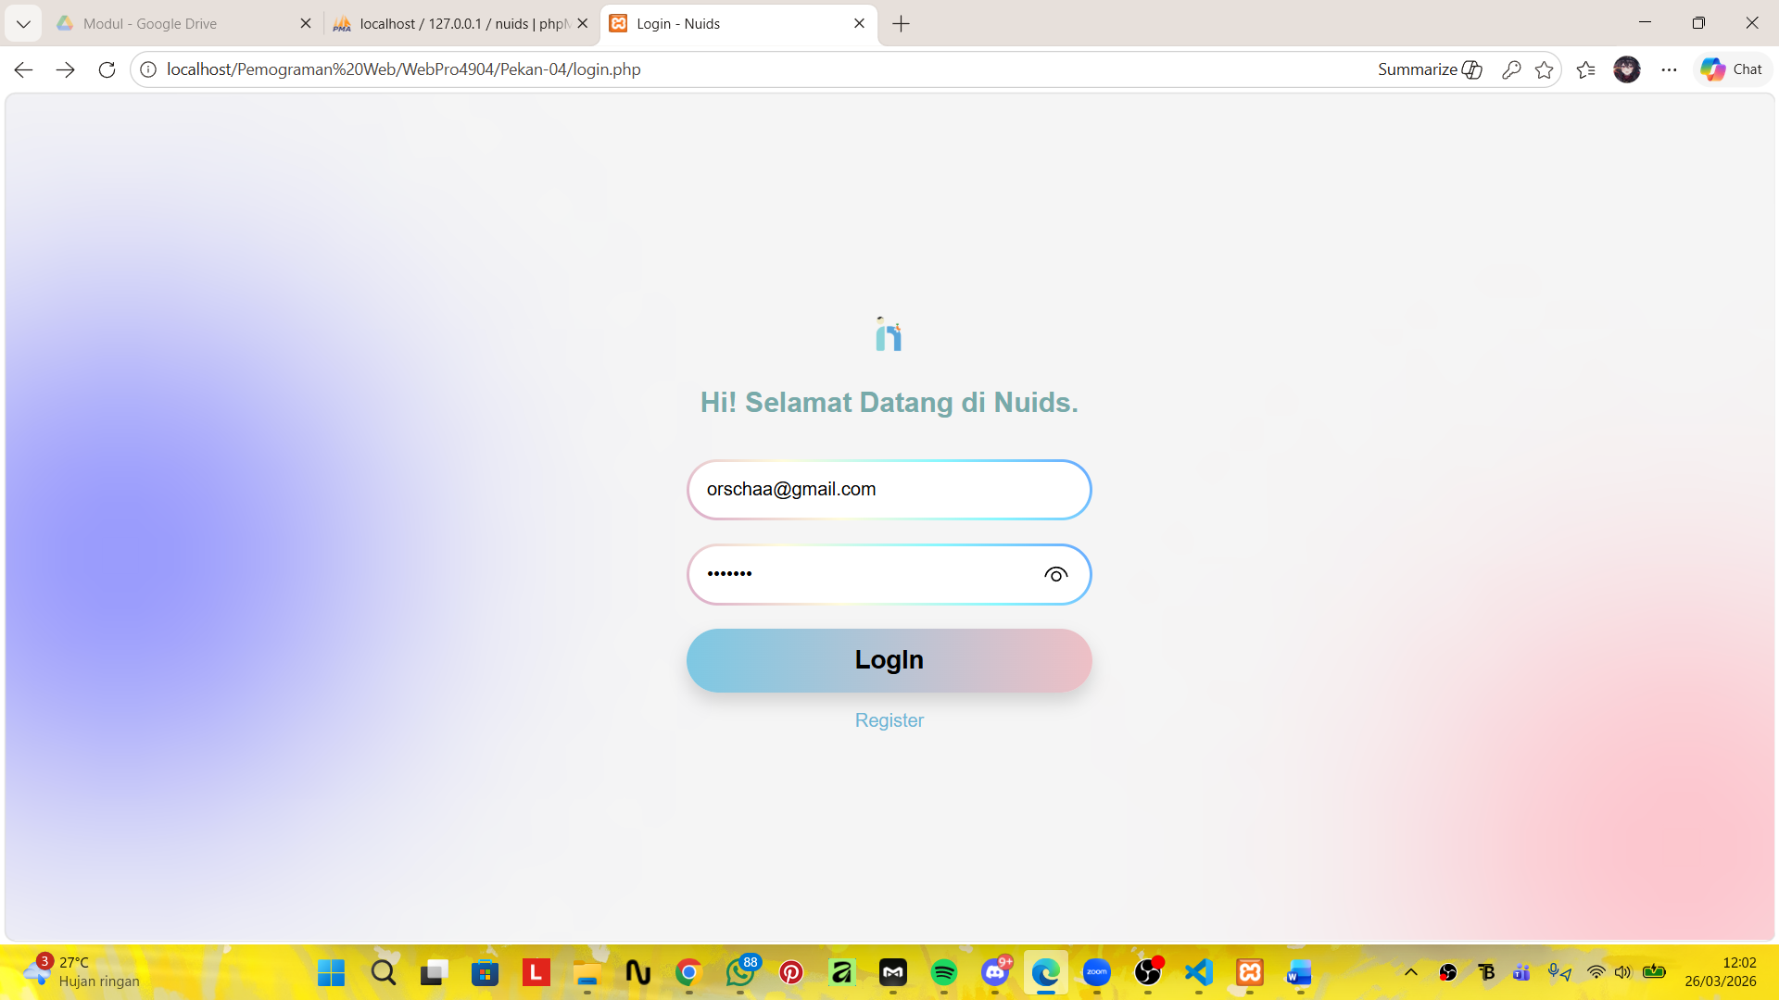
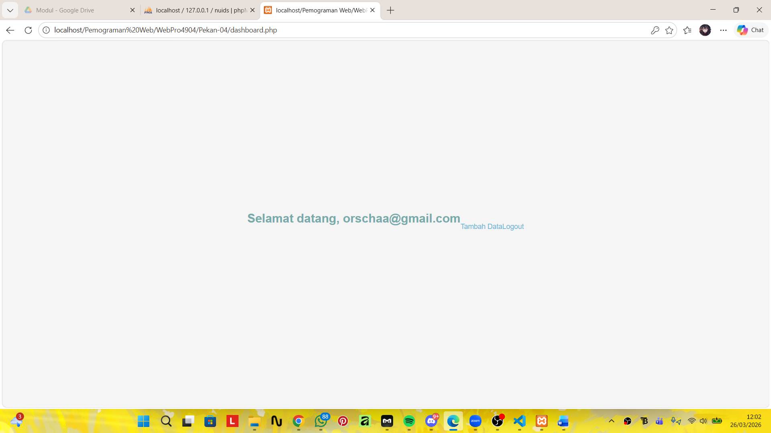
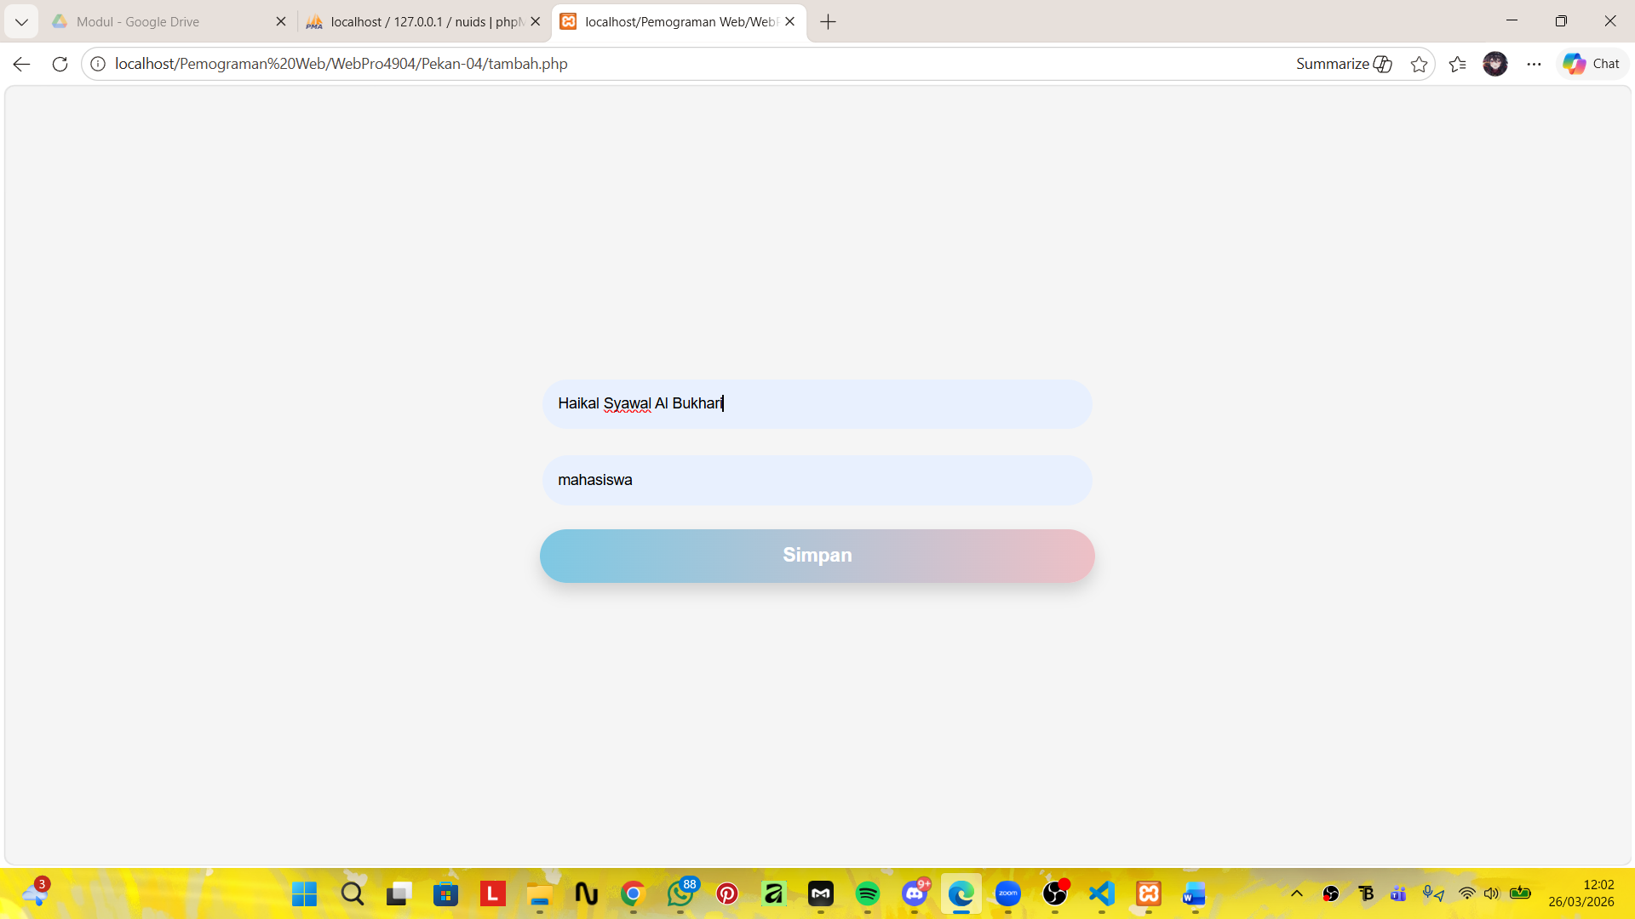
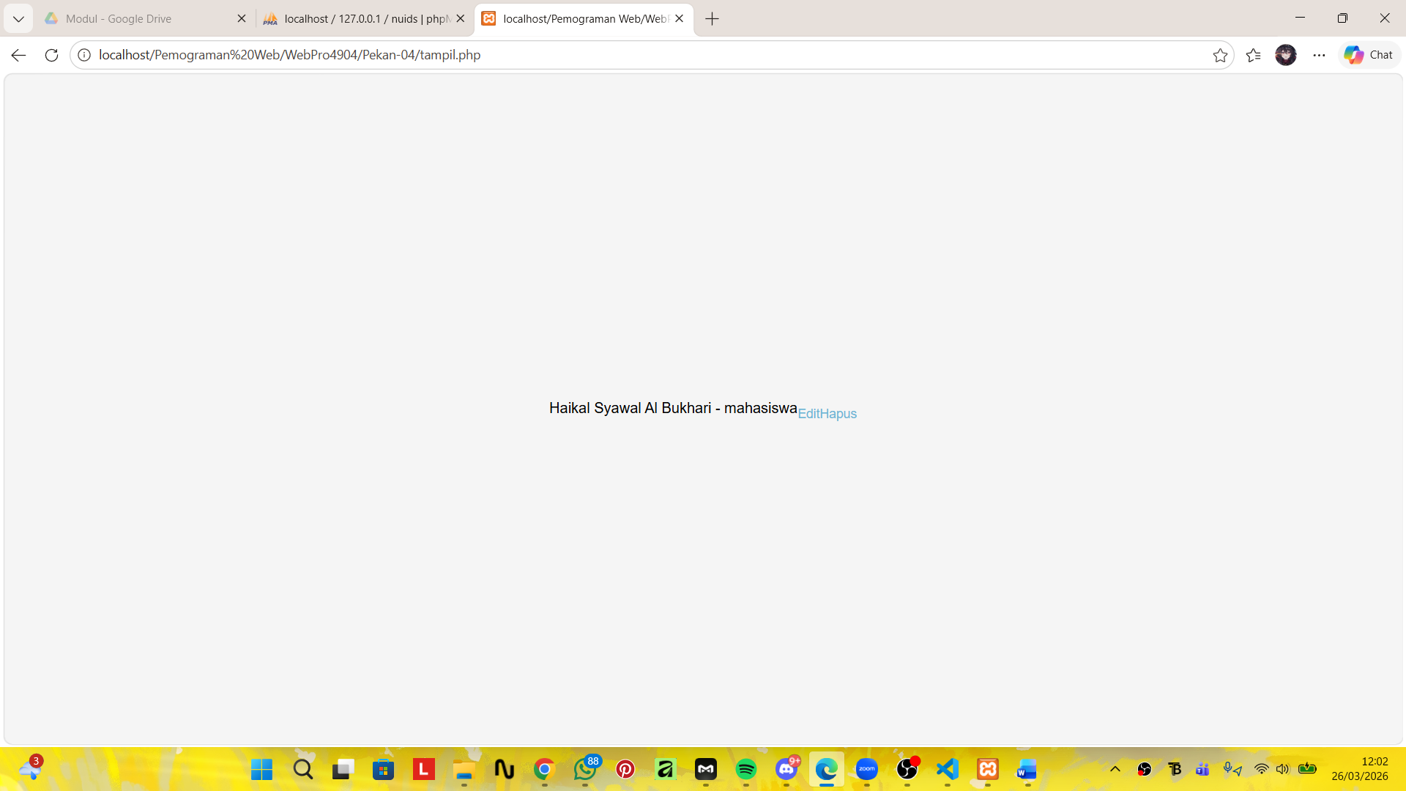
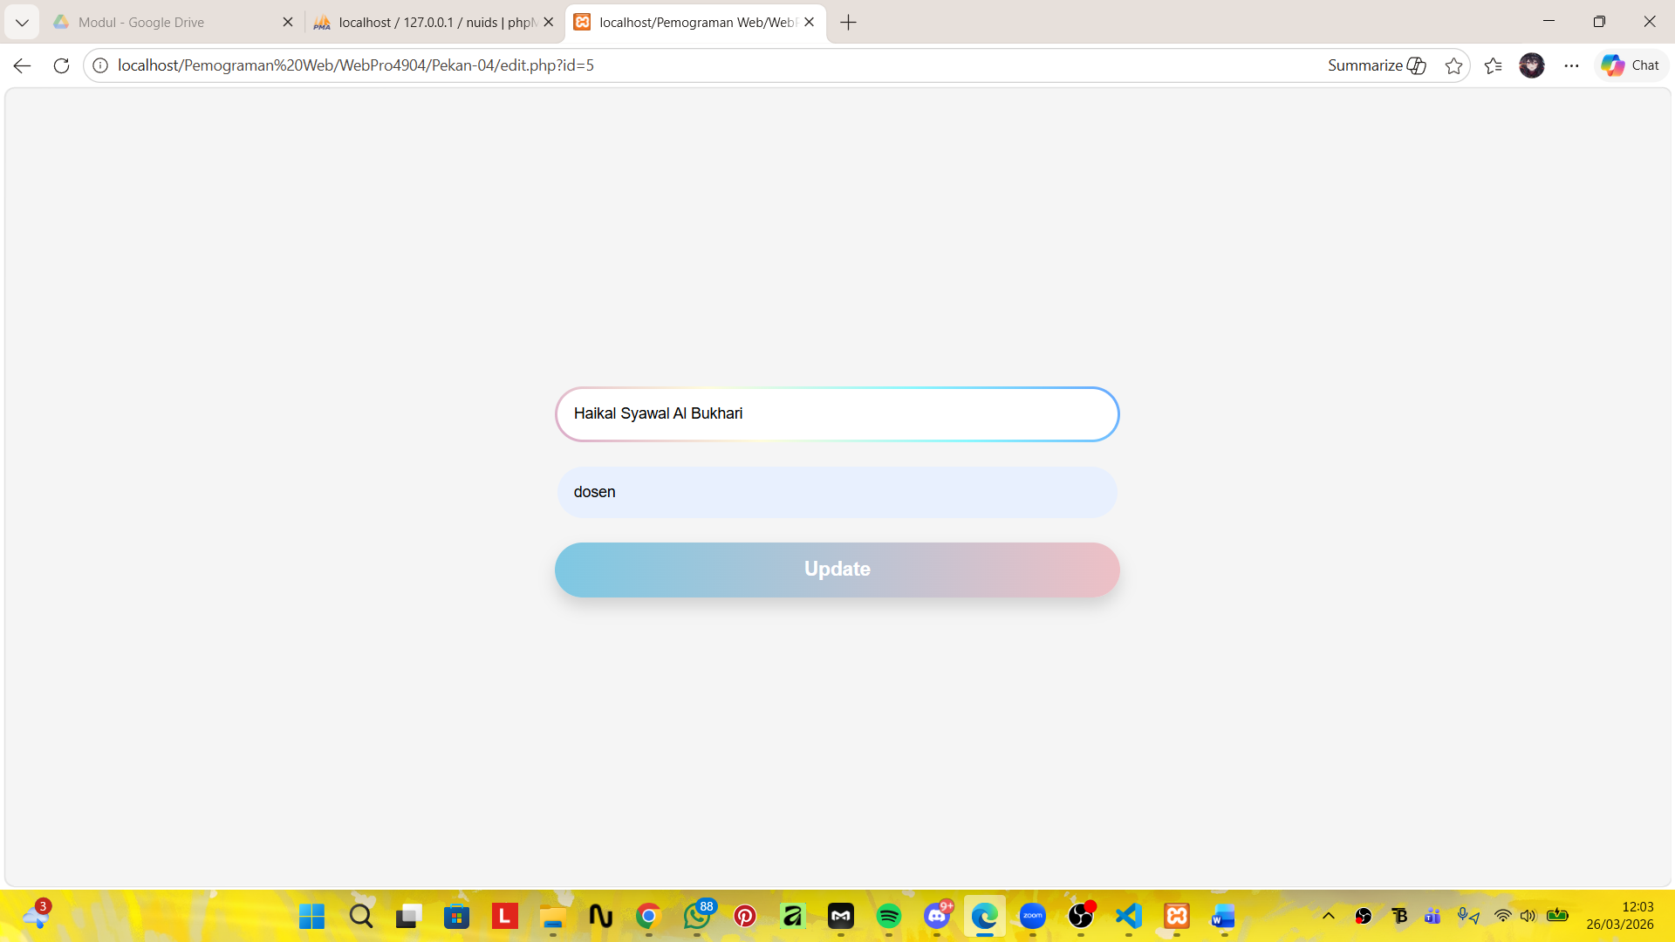
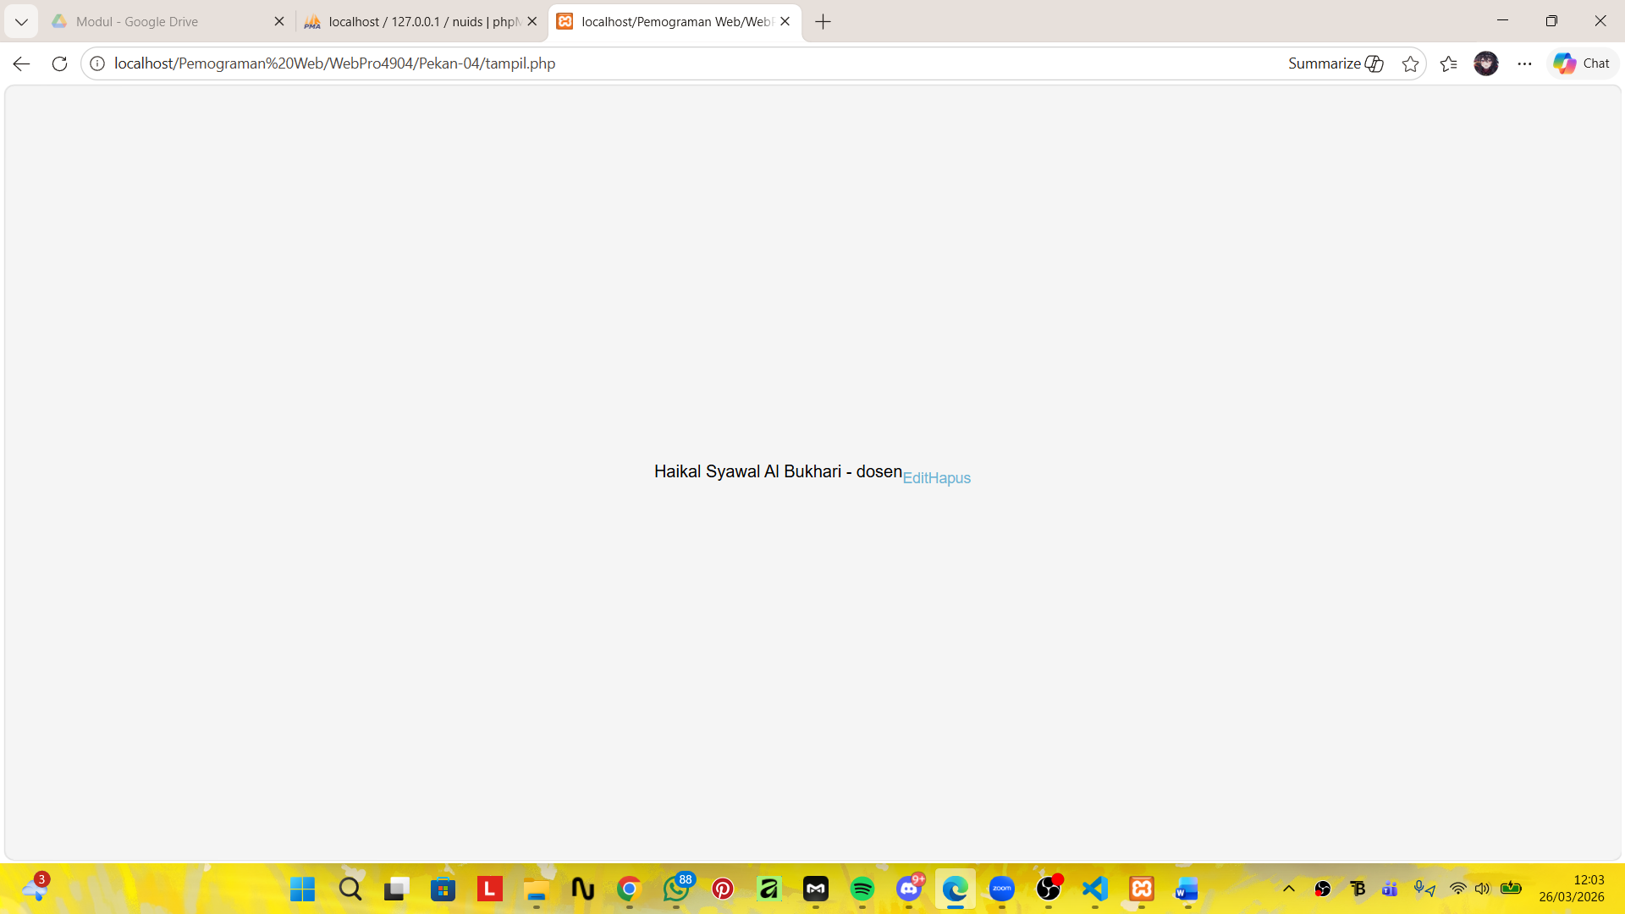
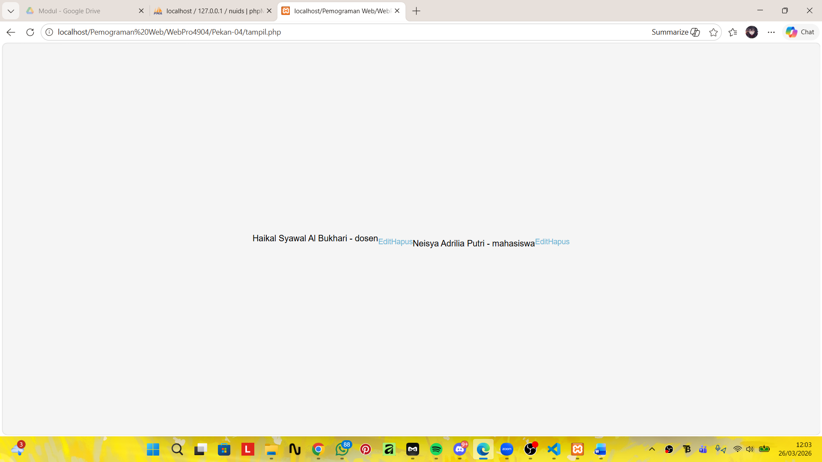
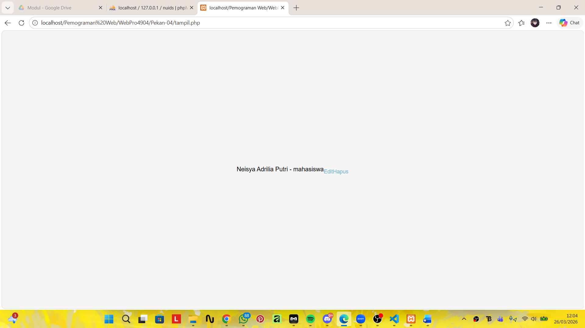

Analisis dan Pembahasan
Koneksi
<?php
$host = "localhost"; //localhost berarti database berjalan di komputer/server yang sama
$user = "root"; //Username untuk login ke database
$password = ""; //Password database
$db = "nuids"; //Nama database yang akan digunakan

$conn = mysqli_connect($host, $user, $password, $db); //Membuat koneksi ke database MySQL

if (!$conn) { //Mengecek apakah koneksi gagal
die("Koneksi gagal: " . mysqli_connect_error()); //Menampilkan pesan error dari MySQL
}
?>

Login
<!DOCTYPE html>
<html lang="id">
<head>
<meta charset="UTF-8">
<meta name="viewport" content="width=device-width, initial-scale=1.0">
<title>Login - Nuids</title>
</head>

<style>
*{
margin:0;
padding:0;
box-sizing:border-box;
font-family: Arial, Helvetica, sans-serif;
}

body{
height:100vh;
display:flex;
justify-content:center;
align-items:center;
background:#f5f5f5;
overflow:hidden;
}

.background .blob{
position:absolute;
width:400px;
height:400px;
border-radius:50%;
filter:blur(120px);
}

.blob1{
background:#7a7cff;
left:-100px;
top:200px;
}

.blob2{
background:#ffb6c1;
right:-120px;
bottom:-120px;
}

.login-container{
text-align:center;
width:350px;
z-index:2;
}

.logo{
width:60px;
margin-bottom:10px;
}

h2{
color:#7aa;
margin-bottom:25px;
}

input{
width:100%;
padding:15px;
margin:10px 0;
border-radius:40px;
border:3px solid transparent;
background:
linear-gradient(white,white) padding-box,
linear-gradient(45deg,#d9a7c7,#fffcdc,#89f7fe,#66a6ff) border-box;
outline:none;
font-size:16px;
}

button{
width:100%;
padding:15px;
border:none;
border-radius:40px;
margin-top:10px;
font-size:22px;
font-weight:bold;
cursor:pointer;

background:linear-gradient(90deg,#7ec8e3,#eec0c6);
box-shadow:0 8px 15px rgba(0,0,0,0.15);
}

.register{
margin-top:15px;
color:#6bb6d6;
cursor:pointer;
}
</style>

<body>

<div class="background">
<div class="blob blob1"></div>
<div class="blob blob2"></div>
</div>

<div class="login-container">

<img src="logo Nuids..png" class="logo">

<h2>Hi! Selamat Datang di Nuids.</h2>

<form method="post" action=""> <!-- disini saya menambahkan method post di dalam form -->
<input name="email" type="email" placeholder="Email" required>
<input name="password" type="password" placeholder="Password" required>

<a href="inputdata.html">
<button type="submit">LogIn</button>
</a>
</form>

<p class="register">Register</p>

</div>

<!-- <?php
// $email = $_POST["email"];
// $password = $_POST["password"];
// if
?> -->

<!-- get -->

<!-- <?php
// if ($_SERVER["REQUEST_METHOD"] == "GET" && isset($_GET['name']) && isset($_GET['email'])) {
// $name = htmlspecialchars($_GET['name']);
// $email = htmlspecialchars($_GET['email']);
// echo "<h3>Hasil Input:</h3>";
// echo "Nama: " . $name . "<br>";
// echo "Email: " . $email;
//}
?> -->

<!-- post -->

<!-- <?php
// if ($_SERVER["REQUEST_METHOD"] == "POST") {
// $name = htmlspecialchars($_POST["name"]);
// $email = htmlspecialchars($_POST["email"]);
// echo "<h3>Data yang Dikirim:</h3>";
// echo "Nama: " . $name . "<br>";
// echo "Email: " . $email . "<br>";
// }
?> -->

<!-- validasi -->

<?php
session_start(); //Memulai session untuk menyimpan data user (misalnya email setelah login)
include "koneksi.php"; //Menghubungkan file koneksi.php (berisi koneksi ke database MySQL)

$email = $password = ""; //pembuatan variabel $email dan $password dengan nilai kosong
$emailErr = $passwordErr = ""; //Variabel untuk menyimpan pesan error jika input kosong

if ($_SERVER["REQUEST_METHOD"] == "POST") { //Mengecek apakah form dikirim menggunakan metode POST

$email = mysqli_real_escape_string($conn, $_POST["email"]); //mysqli_real_escape_string digunakan untuk mencegah SQL Injection
$password = $_POST["password"];

if (empty($email)) {
$emailErr = "Email harus diisi";
}

if (empty($password)) {
$passwordErr = "Password harus diisi";
}

if (!$emailErr && !$passwordErr) {

$query = "SELECT * FROM users WHERE email='$email'"; //query untuk mencari data user berdasarkan email di database
$result = mysqli_query($conn, $query); //Menjalankan query ke database
$data = mysqli_fetch_assoc($result); //Mengambil hasil query dalam bentuk array (data user)

if ($data && password_verify($password, $data['password'])) { //password_verify() digunakan untuk mencocokkan password dengan hash (AMAN)
$_SESSION['email'] = $data['email'];

header("Location: dashboard.php");
exit;
} else {
echo "Login gagal!";
}
}
}
?>

</body>
</html>

Tampil
<style>
*{
margin:0;
padding:0;
box-sizing:border-box;
font-family: Arial, Helvetica, sans-serif;
}

body{
min-height:100vh;
display:flex;
justify-content:center;
align-items:center;
background:#f5f5f5;
overflow:hidden;
}

/* BACKGROUND BLOB */
.background .blob{
position:absolute;
width:400px;
height:400px;
border-radius:50%;
filter:blur(120px);
z-index:0;
}

.blob1{
background:#7a7cff;
left:-100px;
top:200px;
}

.blob2{
background:#ffb6c1;
right:-120px;
bottom:-120px;
}

/* CONTAINER */
.container{
width:380px;
padding:30px;
border-radius:20px;
background:rgba(255,255,255,0.6);
backdrop-filter:blur(15px);
box-shadow:0 10px 30px rgba(0,0,0,0.15);
text-align:center;
z-index:2;
}

/* TITLE */
h2{
margin-bottom:20px;
color:#7aa;
}

/* TEXT */
p{
margin-bottom:15px;
color:#555;
}

/* INPUT */
input{
width:100%;
padding:15px;
margin:10px 0;
border-radius:40px;
border:3px solid transparent;
background:
linear-gradient(white,white) padding-box,
linear-gradient(45deg,#d9a7c7,#fffcdc,#89f7fe,#66a6ff) border-box;
outline:none;
font-size:14px;
}

/* BUTTON */
button{
width:100%;
padding:15px;
border:none;
border-radius:40px;
margin-top:10px;
font-size:18px;
font-weight:bold;
cursor:pointer;

background:linear-gradient(90deg,#7ec8e3,#eec0c6);
box-shadow:0 8px 15px rgba(0,0,0,0.15);
color:white;
transition:0.3s;
}

button:hover{
transform:scale(1.05);
}

/* LINK */
a{
display:block;
margin-top:12px;
text-decoration:none;
color:#6bb6d6;
font-size:14px;
}

/* DATA CARD */
.data-item{
background:rgba(255,255,255,0.7);
padding:12px;
margin:10px 0;
border-radius:15px;
text-align:left;
box-shadow:0 5px 15px rgba(0,0,0,0.1);
}

.data-item b{
color:#444;
}

.data-item a{
display:inline;
margin-right:10px;
font-size:12px;
color:#ff7a7a;
}
</style>

<?php
include "koneksi.php";

$data = mysqli_query($conn, "SELECT * FROM data");

while ($row = mysqli_fetch_assoc($data)) {
echo $row['nama'] . " - " . $row['keterangan'];
echo " <a href='edit.php?id=".$row['id']."'>Edit</a>";
echo " <a href='hapus.php?id=".$row['id']."'>Hapus</a><br>";
}
?>

Tambah
<style>
*{
margin:0;
padding:0;
box-sizing:border-box;
font-family: Arial, Helvetica, sans-serif;
}

body{
min-height:100vh;
display:flex;
justify-content:center;
align-items:center;
background:#f5f5f5;
overflow:hidden;
}

/* BACKGROUND BLOB */
.background .blob{
position:absolute;
width:400px;
height:400px;
border-radius:50%;
filter:blur(120px);
z-index:0;
}

.blob1{
background:#7a7cff;
left:-100px;
top:200px;
}

.blob2{
background:#ffb6c1;
right:-120px;
bottom:-120px;
}

/* CONTAINER */
.container{
width:380px;
padding:30px;
border-radius:20px;
background:rgba(255,255,255,0.6);
backdrop-filter:blur(15px);
box-shadow:0 10px 30px rgba(0,0,0,0.15);
text-align:center;
z-index:2;
}

/* TITLE */
h2{
margin-bottom:20px;
color:#7aa;
}

/* TEXT */
p{
margin-bottom:15px;
color:#555;
}

/* INPUT */
input{
width:100%;
padding:15px;
margin:10px 0;
border-radius:40px;
border:3px solid transparent;
background:
linear-gradient(white,white) padding-box,
linear-gradient(45deg,#d9a7c7,#fffcdc,#89f7fe,#66a6ff) border-box;
outline:none;
font-size:14px;
}

/* BUTTON */
button{
width:100%;
padding:15px;
border:none;
border-radius:40px;
margin-top:10px;
font-size:18px;
font-weight:bold;
cursor:pointer;

background:linear-gradient(90deg,#7ec8e3,#eec0c6);
box-shadow:0 8px 15px rgba(0,0,0,0.15);
color:white;
transition:0.3s;
}

button:hover{
transform:scale(1.05);
}

/* LINK */
a{
display:block;
margin-top:12px;
text-decoration:none;
color:#6bb6d6;
font-size:14px;
}

/* DATA CARD */
.data-item{
background:rgba(255,255,255,0.7);
padding:12px;
margin:10px 0;
border-radius:15px;
text-align:left;
box-shadow:0 5px 15px rgba(0,0,0,0.1);
}

.data-item b{
color:#444;
}

.data-item a{
display:inline;
margin-right:10px;
font-size:12px;
color:#ff7a7a;
}
</style>

<?php
include "koneksi.php";

if (isset($_POST['submit'])) {
$nama = $_POST['nama'];
$ket = $_POST['keterangan'];

mysqli_query($conn, "INSERT INTO data (nama, keterangan) VALUES ('$nama','$ket')");
header("Location: tampil.php");
}
?>

<form method="post">
<input type="text" name="nama" placeholder="Nama">
<input type="text" name="keterangan" placeholder="Keterangan">
<button name="submit">Simpan</button>
</form>

Edit
<style>
*{
margin:0;
padding:0;
box-sizing:border-box;
font-family: Arial, Helvetica, sans-serif;
}

body{
min-height:100vh;
display:flex;
justify-content:center;
align-items:center;
background:#f5f5f5;
overflow:hidden;
}

/* BACKGROUND BLOB */
.background .blob{
position:absolute;
width:400px;
height:400px;
border-radius:50%;
filter:blur(120px);
z-index:0;
}

.blob1{
background:#7a7cff;
left:-100px;
top:200px;
}

.blob2{
background:#ffb6c1;
right:-120px;
bottom:-120px;
}

/* CONTAINER */
.container{
width:380px;
padding:30px;
border-radius:20px;
background:rgba(255,255,255,0.6);
backdrop-filter:blur(15px);
box-shadow:0 10px 30px rgba(0,0,0,0.15);
text-align:center;
z-index:2;
}

/* TITLE */
h2{
margin-bottom:20px;
color:#7aa;
}

/* TEXT */
p{
margin-bottom:15px;
color:#555;
}

/* INPUT */
input{
width:100%;
padding:15px;
margin:10px 0;
border-radius:40px;
border:3px solid transparent;
background:
linear-gradient(white,white) padding-box,
linear-gradient(45deg,#d9a7c7,#fffcdc,#89f7fe,#66a6ff) border-box;
outline:none;
font-size:14px;
}

/* BUTTON */
button{
width:100%;
padding:15px;
border:none;
border-radius:40px;
margin-top:10px;
font-size:18px;
font-weight:bold;
cursor:pointer;

background:linear-gradient(90deg,#7ec8e3,#eec0c6);
box-shadow:0 8px 15px rgba(0,0,0,0.15);
color:white;
transition:0.3s;
}

button:hover{
transform:scale(1.05);
}

/* LINK */
a{
display:block;
margin-top:12px;
text-decoration:none;
color:#6bb6d6;
font-size:14px;
}

/* DATA CARD */
.data-item{
background:rgba(255,255,255,0.7);
padding:12px;
margin:10px 0;
border-radius:15px;
text-align:left;
box-shadow:0 5px 15px rgba(0,0,0,0.1);
}

.data-item b{
color:#444;
}

.data-item a{
display:inline;
margin-right:10px;
font-size:12px;
color:#ff7a7a;
}
</style>

<?php
include "koneksi.php"; //Menghubungkan file koneksi.php

$id = $_GET['id']; //Mengambil nilai id dari URL
$data = mysqli_query($conn, "SELECT * FROM data WHERE id=$id"); //Menjalankan query untuk mengambil data berdasarkan id
$row = mysqli_fetch_assoc($data); //Mengambil hasil query dalam bentuk array

if (isset($_POST['submit'])) {
$nama = $_POST['nama'];
$ket = $_POST['keterangan'];

mysqli_query($conn, "UPDATE data SET nama='$nama', keterangan='$ket' WHERE id=$id"); //Menjalankan query UPDATE ke database
header("Location: tampil.php");
}
?>

<form method="post">
<input type="text" name="nama" value="<?php echo $row['nama']; ?>">
<input type="text" name="keterangan" value="<?php echo $row['keterangan']; ?>">
<button name="submit">Update</button>
</form>

Hapus
<?php
include "koneksi.php";

$id = $_GET['id'];

mysqli_query($conn, "DELETE FROM data WHERE id=$id"); //Menjalankan query DELETE ke database

header("Location: tampil.php"); //Setelah data dihapus → diarahkan ke halaman tampil.php
?>

Kesimpulan
Praktikum kali ini kami diajarkan bagaimana cara menghubungkan web kita ke database menggunakan MySQL

